- Name the element based on the Bohr’s Model. (Picture to the right)

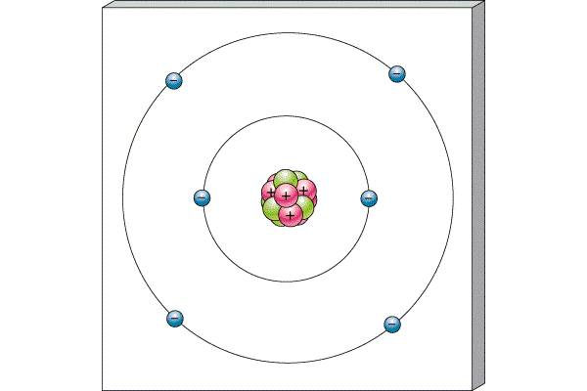
- How do you know this represents that element? Explain how you found your answer.

- What are two ways of finding valence electrons?

- How many valence electrons does the atom to the right have?

- How do you find neutrons of an atom?

- How many neutrons does Silicon (Si) have?

- Name the three types of bond and give define them.

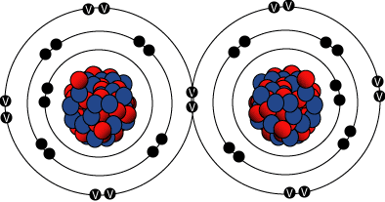

- What type of bond is pictured to the right?

- Which of the three types of bonds is the weakest and explain why.

- Explain what a chemical reaction is in relationship to bonding.

- Label the parts of the atom below: electrons, protons, neutrons
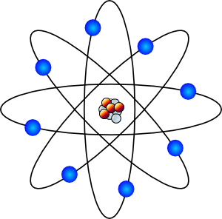

- Describe the difference between subscripts and coefficients.

- What is a chemical reaction and give examples of how we know one is occurring?

- How is water (H₂O) different from its ingredients of just H and O?

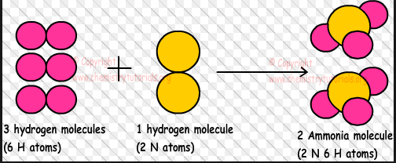
Please use this picture for questions 16 & 17.

__________________________ _______________________
- Label the reactants and products of the equation above.
- How does this equation prove Law of Conservation of Mass?

- Please use the statement below to figure out the amount of substance needed to prove the Law of Conservation of Mass for this equation. (Fill in the blank)
10 grams of water + _______ g of salt = 15 grams of salt water

- Look at the equation below and diagram how you know it is balanced. (Count the atoms on both sides)
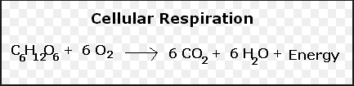

      - C: C:
      - O: O:
      - H: H:
- Draw a roller coaster with large potential energy?

- Now diagram where the roller coaster would have the highest PE and KE.

- A car sits parked not running in a parking lot. Is it using energy, and why?

- Describe all the energy transformations associated with fireworks from when it is lit to after the show. (Hint: Start with chemical potential)
Chemical potential →____________________, _______________________, and ___________________
- What type of energy do you have when it is held and not used (stored energy)?

- Describe the speed of the particles of cheese melting in a crock pot (fast, medium, slow). How do you know this?

- Why would a person use a wooden stick to move a live electrical line? What property does the wooded stick exhibit?

- How is the Law of Conservation of Energy similar to the Law of Conservation of Mass?

- Describe the energy transformations for each of the following.
  - Battery powering and alarm clock: ________________ to ________________
  - Motor running a lawn mower: ________________ to ________________
  - Solar Panel powering a calculator: ________________ to ________________
  - TV turned on: ________________ to ________________

- For the following examples, decided if it explains Conduction, Convection, or Radiation. Provide at least a one sentence explanation describing why/how it illustrates the concept. (Write your answer under the letter)
- Spoon in hot soup b. Sun’s rays on earth c. Boiling Noodles

- List two examples of Convection

- List two examples of Conduction

- List two examples of Radiation

- What is heat transfer?

Use the pictures below to help answer question 34.
Pot of Soup (38 °C) Tub (38 °C)
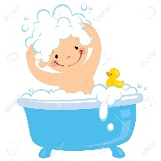
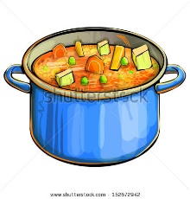

- Which do you think has greater thermal energy? (Think of the mass the containers can hold)

- List and describe the 5 Spheres of the Earth.

- Give one example of how at least 2 spheres interact with each other.

